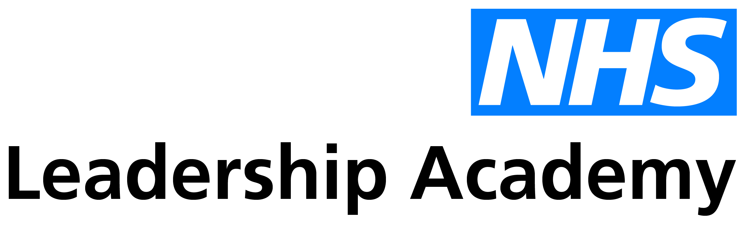

Overview of benefits

Talent Management

www.leadershipacademy.nhs.uk

Talent management benefits

The benefits of successfully embedding talent management are numerous and varied. Below we have summarised some of the key longer-term benefits that the organisation can expect to achieve following successful implementation:

- A driver of culture change – A talent management process that is underpinned by organisational values and behaviours will reinforce culture change. This works through ensuring that part of the way that ‘talent’ is defined is down to the extent to which individuals are displaying the behaviours required to drive the desired culture.

- Improved staff and patient experience – there are multiple sources of evidence that suggest that clarity of goals/objectives can contribute to higher levels of staff engagement as well as better health and well-being, and that meaningful appraisal systems can also reduce patient mortality and improve patient safety.

- A lever to support diversity and inclusion - through the introduction of accessible talent management approaches which support individuals to achieve their potential irrespective of their personal or professional backgrounds, the value of diversity and inclusion in the workforce can be more widely recognised and maximised.

- Greater attraction of talent – Organisations that place a strong emphasis on finding and developing talented staff soon build a reputation as such. Research demonstrates a correlation between how desirable external applicants rate potential employers as a place to work with whether or not they have established talent management processes. It is thought that this is less to do with people’s awareness of the process itself but more that ‘good’ people attract ‘good’ people.

- Enhanced relationship between individuals and managers - Talent management increases the frequency of interaction between an individual and their manager. It also enhances the depth of conversation and degree of focus around an individual’s personal needs and development priorities. Given the majority of research tells us that the relationship between an individual and their manager has the greatest influence on their performance this is a very valuable outcome.

- A voice for ambition – Conventional appraisal processes when operating without talent management make it hard for individuals to share their ambitions and when they do it is often difficult for managers to know what to do with this information. The implementation of robust talent management should make it easier for individuals to signal their intent, receive the support they need to make a transition and ultimately to move into another role or the support they need to maintain and/or enhance their performance in their current role.

- More tailored individual development - Talent management takes into account all aspects of an individual’s make-up e.g. their potential, aspirations, confidence, capability and personal needs. It allows development plans to be more targeted, motivating and achievable and is ultimately a key enabler to getting the best out of people.

- Greater pipeline intelligence – Without talent management and succession planning an organisations understanding of individuals’ aspirations and readiness is limited at best. Having greater insight into where the leadership pipeline is flowing and where it is not supports effective workforce planning and allows the organisation to ensure business continuity when there are unanticipated departures / absence.

- Improved retention – implementing effective talent management approaches can also aid retention. High quality talent management processes place emphasis on meaningful conversations with staff which can increase their sense of value, resulting in a positive impact and experience for patients and service users. Increased partnership working and development of wider opportunities can also help to retain staff in local organisations and systems.

- Enhanced succession planning - summarising the relationship between performance, potential, aspiration and readiness is conducive to the production of robust succession plans. This information gives a clear indication of whether someone is ready or keen to step into another role or area of capability and also what might be required to get them to this point. Effective talent management provides succession data by default.

- A clearer understanding of national and regional talent management challenges – allowing strategic solutions to benefit the system as a whole. By ensuring some consistency in the use of talent management practices across the NHS, we can begin to form an improved understanding of national talent challenges and where appropriate, develop system-wide solutions to support organisations to address them.

