Review and Career Conversation Training for Managers

Participant Workbook

www.leadershipacademy.nhs.uk

Activity 1- Building relationships

The quality of the relationship you have with individuals of your team can significantly impact the quality of the conversation you will be having about their performance, potential, aspirations and readiness.
Take a few moments to reflect on your assessment of the level of trust that exists between you and different team members:
- Where would you place them on the grid below?
- What are the positive aspects of these relationships?
- What are your perceptions as to what works less well?
- Why? Where would you like the relationship to be? What action could you take to improve this?

Level | Team Members

Peak rapport

Feelings and emotions

Ideas and opinions

Facts and information

Ritual Cliché

Additional observations:

Activity 2 – Changing behaviour

Identify at least one behaviour you would want to change in one of your team members:
Why does it need to change?
What could the impact be if this behaviour doesn’t change?

Activity 3 – Planning feedback

- Think about a team member you need to deliver some feedback to and summarise the situation briefly below
- Consider which approach to giving feedback the would be the best to take
- Construct the piece of feedback
- You’ll be practicing delivering these messages later on the course
Describe this person’s character and how do they behave e.g. formal or informal, loud or quiet, quick or slow, serious or relaxed, and any particular mannerisms they display
What is the background/history of your management of this person to date?
How are they likely to respond to the piece of feedback you are going to give them? (think SARA)

B | Behaviour – be specific about what you observed
E | Effect – Either ask a question to find out what they think, or describe your views
E | Expectation – Either ask a question or share your views. Consider which group to refer to in terms of impact
R | Result – Ask a question, share your views or leave it open….what will work best for the person?

Activity 4 – Giving feedback

Person 1 – Gives feedback: briefly describes to person 2 the summary of the person they’re giving feedback to using notes on page 23 and delivers the piece of feedback to person 2 using BEER preparation from page 24.

Person 2 – Receives feedback: may interact with person 1 if they wish and display SARA to see how person 1 reacts.

Person 3 – Observes the feedback: notes how person 1 delivers and how person 2 receives. Asks 1 and 2 how they felt about delivering and receiving and then passes on their own observations – including one effective thing they did and one thing they could improve upon/consider when they are doing it for real.

Delivering feedback
- Positions feedback
- Covers behaviour
- Covers effect
- Covers expectation
- Covers result

Receiver of feedback
- Reaction (verbal and non-verbal)

Your observations

- What worked well

- One thing to improve upon

Activity 5 – Shaping Goals

Work in pairs to write a real work goal/objective (below) for a member of your team that links to your team/service delivery plan.

Activity 6 – Supporting development

Using one of the work goals you’ve created:

Speculate on what skills, knowledge or behaviour might need to be developed in order to deliver against that objective

Identify at least two different ways for that development to happen:

Activity 7 – Planning a conversation

Date and time – when would be most suitable?
What location will be the best place to hold a review and career conversation with this person?
What kind of leadership style might work best with this individual? Why?
How will you know it has been a successful?

What challenges do you anticipate?
What preparation do you need to do?
What do you need them to prepare?
How will you communicate this to them?
How are you going to start the meeting?

How are you going to build rapport (in the run up to and during the meeting)?
What approach are you going to take to giving feedback?
Give an example

Briefly describe one of the goals/objectives you need to set for this individual using SMART
What kinds of development could help this individual achieve their objectives/fulfil their aspirations?

Activity 8 – Your reflections

Thoughts, take aways and reflections on today:
Hints, tips and further information

The Review and Career Conversation

The Review and Career Conversation provides a structure for individuals and their reviewer to have regular conversations. It is intended to combine appraisal, career conversations, review of health and wellbeing and personal development planning in a single joined-up conversation.
The conversation is based upon the following principles.
- the quality of the conversation itself in the first priority,
- its focus is individualised, humanistic and based on you, your role and career,
- it happens frequently and is complimented through regular one-to-ones
- it assumes your life, career, motivations and performance are subject to change
- it promotes an adult and respectful relationship between you and your employer

and what it is not…
- A way of categorising you or putting you in a box
- A judgemental process that makes rigid assumptions about your future
- A way of dealing with performance issues or having difficult conversations

Getting it right
Prepare!

Build rapport; listen and understand the person
Familiarise yourself with how it works

Set clear goals
Provide constructive feedback and support

Your preparation

To keep the discussion focused and maximise the quality of the conversation it is recommended that you also complete the following sections of the Review in advance. It is anticipated that this will take you approximately 30 minutes.
Section 2 – Reviewing my goals and objectives
Refer back to the goals and objectives agreed during your last conversation and rate each of them. It can be helpful for each of you to share your thoughts and ratings before the conversation, but you will need to agree this between you.
Section 3 – Reviewing my behaviour
It is recommended that you rate the individual’s behaviours in advance of the meeting. It can be beneficial to canvass other people’s thoughts and feedback before you do this, but always check that the individual is happy for you to do this.
Section 4 – Reviewing my career
If you know that the person you are meeting is interested in exploring other career options at this point and is completing the Reviewing My Potential section, then you will also need to rate them against these criteria.

Questioning tips

Use these types of question to elicit more details:

Open questions – Who, What, When, Where, Which, Why, How?

Probing questions – What happened next? Tell me more. What do you mean by that? What did you specifically do?

Comparative questions – How do you think your responsibilities now compare to those you had a year ago?

Feedback questions – What feedback did you get on that?

Reflective questions – What did you learn from that? In retrospect, what would you do differently?

Using rating scales

One aim as part of the review is the objective collection and clear expression of evidence. Accurate and clearly documented observations about how your team members have performed are critical to the discussion. It is important to summarise the observations against each value. You should then assign a rating based on the evidence you have as to the extent to which the individual has displayed the behaviour.

- Weigh up the positive and negative
- Consider what was missing - ‘evidence by omission’
- Strong and weak evidence
- Refer to the behaviour definitions

Sources of error
It is inevitable that our own attitudes will have an effect on how we rate individuals. The aim of behavioural assessment processes is to ensure that these have as little impact as possible. A number of biases have been identified which you need to be aware of when rating performance. Bias in either direction can result in a reduction in objectivity and may mean that evaluations are unduly influenced by irrelevant factors. Common biases to be mindful of include:

- Halo effect - generalising one aspect of good performance to all performance
- Horns effect - generalising one aspect of poor performance to all performance
- Central tendency - giving “middle of the road” evaluation to avoid high or low ratings
- Leniency - generally viewing performance favourably
- Harshness - generally viewing performance unfavourably
- First impressions - tendency to be influenced by initial impressions and disregard subsequent contrary evidence
- Recency - tendency to be influenced by last observation made and disregard earlier contrary evidence
- Stereotyping - allowing personal bias/prejudice to distort evaluation of performance
- Rushed decision making – spending insufficient time evaluating performance
- Lack of concentration – Not focusing on the review process/allowing distractions leading to misinterpretation of or gaps in evidence
- Similarity/attractiveness - making assumptions about the individual’s performance based on your own preferences or their appearance
- Priming – a form of unconscious working memory which causes people to be sensitive to certain types of information
- Attribution bias – the tendency to place undue emphasis on the impact of someone’s personality to explain their behaviour rather than considering the impact of their current situation

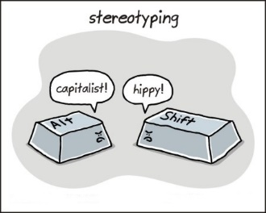 | To minimise sources of error it is useful to:  - Be aware of potential biases  - Do your preparation  - Be aware of and check your own strong opinions  - Challenge yourself and others – what evidence are you using?

Feedback

The giving and receiving of feedback is of vital importance if individuals are going to learn from their experiences. Feedback offers crucial insights into how others see them and gives them the opportunity to reciprocate and is a process fundamental to increasing the performance of people in organisations.

Feedback is information about a person’s behaviour and the effect it has. It stems from a positive intention to help the person increase their self-awareness and motivate them to make better choices in order to improve their impact. You need to plan your feedback carefully to ensure it is effective.

Responses to feedback
Upon receiving feedback individuals might experience a range of reactions in response to the information they are hearing. Although negative feedback is commonly the most difficult to take, positive feedback can also be awkward for some. People will often give rise to defence mechanisms as a result. Reactions include aggression, blaming others and making excuses. One of the easiest ways to remember the different emotional states is SARA. Notice what stage a person might be at – some people move very quickly through the stages. Others may get stuck on one particular stage for a while.
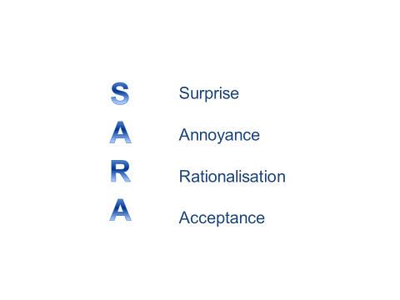

Feedback models

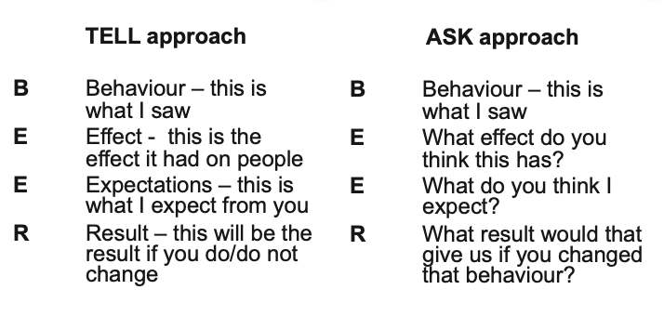

Use the most appropriate model for feedback; think about the person, the situation and the impact you want to have
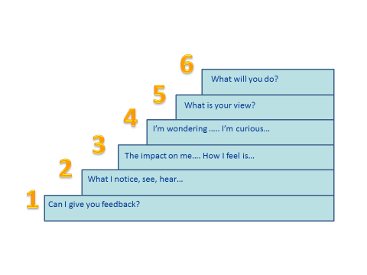

Focus for feedback
A solutions focus can be very helpful when you want to frame change in a positive way. The solutions focused approach is well-founded in practice around the world. It is characterised by a positive and pragmatic approach to change, helping people to identify and carry out small carefully-targeted actions to promote what they want.
This approach values simplicity in philosophy and language and aims to discover "what works" in a given situation, simply and practically. The focus on solutions (not problems), the future (not the past) and on what's going well (rather than what's gone wrong) leads to a positive and pragmatic way to work with organisations and individuals.
Two basic principles of solutions focus
- Find what works and do more of it
- If it’s not working, do something different

Problem Focus | Solutions Focus
Weaknesses and deficits | Strengths and successes
Reducing weaknesses | Using strengths
Discussing failures in the past | Future orientation – how we (both) want it to be

Potential questions to get a “solutions focus” when reviewing the past……
- What have you done well?
- When did you do better than you thought you might?
- What’s the very best you’ve ever done?
- What went well on that occasion?

Focusing on the positive also gives us a useful approach when moving on to think about the future.

Influencing through conversation
 |  | 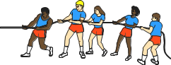
Push |  | Pull
Choose your style of communication – Push or Pull?
You influence by working to your agenda, and the other person modifies their position:  - Give your views and opinions:  “I think…” “in my opinion….”  - Express your feelings:  “I’m frustrated about…” “I’m anxious about…”  - State your expectations:  “I want you to…” |  | You influence by working to their agenda and you modify your position:  - Actively listen – reflecting data, feelings and summarising  - Use questions to increase your understanding of the other person’s position  - Focus and build on common ground
When to use the styles
Use Push when:  - There are clear rules to be obeyed  e.g. Health and Safety  - You need to succeed  e.g. critical negotiations  - There is a right way to do things  e.g. to maintain quality  - You need quick results |  | Use Pull when you:  - Need to get people’s commitment  - Need to improve things  - Are dealing with uncertainty e.g. change  - Manage the long term and have time to talk
Make sure your voice and body language match the style you are using
 | Push | Pull
Voice | Strong. Emphasis on key points. Steady, brisk pace. | Softer, gentle tone, slower pace.
Eyes | Looking directly when speaking. | Direct, particularly when listening.
Posture | Upright, sometimes leaning forward. | Leaning back, more laid-back posture, respecting personal space.
Hands | Emphatic gestures to “underline” points. | Open gestures e.g. palms up, keeping hands still.

Tactics for Influencing
Push and Pull can be broken down further into four Influencing styles involving many different behavioural tactics, all of which can be used in an organisational context. Each of them may be deployed to successfully persuade people to voluntarily change their attitudes towards events, people and decisions so that your ideas are the ones that get implemented. You will find that some tactics come more easily to you than others, developing a broader range of approaches is essential for leaders.

PUSH Styles | Influencing tactic
Reward & Punishment | - Statements beginning with “I expect….I want….I need…..” that are not supported by logical arguments  - Specifying the implications of doing or not doing something  - Giving out praise or blame from a personal viewpoint only  - Identifying personal favours that will need to be repaid at some point.
Business Logic | - Proposing ideas/suggestions supported by rational business arguments  - Discussion of reasons for/against a particular proposal  - Use of data and evidence to back up statements  - Questions/discussions that explore the logic behind ideas  - Evaluating ideas/suggestions rationally

PULL Styles
Participation & Trust | - Inviting others to be part of the decision making and planning process  - Soliciting the views and ideas of others  - Acknowledging the strengths/expertise of others and allowing them to use it  - Asking open questions and using positive body language to encourage the participation of others  - Statements that develop a sense of ownership and commitment; use of lots of “We….” sentences.
Common vision | - Exploring common ground by questioning and listening  - Checking understanding by summarizing and reflecting back  - Highlighting areas of agreement (ideas, values, beliefs)  - Appealing to the values of others in order to generate enthusiasm  - Using emotionally charged language to inspire others towards mutual goals

Handling challenges during the conversation

If the individual is: | You might be feeling…. | You might be tempted to…. | You might find it useful to…..
Passive | Annoyed  Frustrated  Embarrassed  Worried | Keep talking  Show your frustration  Answer your own question  Pressurise the person | Use silence  Be patient  Show empathy  Use a variety of questions
Upset | Sympathetic  Guilty  Pleased that you have finally got through to them  Confused | Soften and back away from the feedback  Change the subject  Make negative mental judgement  Leave them alone | Show empathy  Give them time  Accept their feelings and allow them to express themselves  Stick to the issue in a gentler manner
Defensive | Uncomfortable  Annoyed  Attacked  Nervous  Intimidated  Irritated | Attack back  Avoid of that issue  Give in  Be aggressive | Paraphrase  Let them talk  Accept valid criticism  Re-state the feedback in a behavioural way  Give specific examples  Count to ten
Closed | Suspicious  Frustrated  Apprehensive | Give in and agree  Accept the blame  Move on to another issue | Use an assertive tone of voice  Use direct eye contact  Use open and probing questions to check understanding  Agree tight action plans

Goals and objectives

These cascade down from the business plan which is our road-map for how we will deliver our goals. Your manager will have agreed your objectives with you, you then need to cascade these down into specific objectives for your team and each of the individuals who report to you.
This section will be easier to agree and complete with your people once you have had your own conversation and clarified the objectives for yourself as a manager and for your team.
Remember to use SMART as a mnemonic to help make your objectives robust. Clarity at this point makes reviewing the outcomes very straightforward later; if you aren’t clear about what you note down as objectives you could have a lot of debate later on!
S | Specific | Be tight and pin down exactly what you mean
M | Measurable | Think of the most appropriate measures; be innovative if you need to be!
A | Agreed | If people don’t agree, it is unlikely to happen
R | Realistic | Challenging and yet achievable objectives are proven to enhance performance
T | Time-bound | Dates, milestones, timelines

CLEAR is an alternative model – as follow:
- Collaborative (Goals should encourage employees to work together collaboratively and in teams)
- Limited (Goals should be limited in both scope and duration)
- Emotional (Goals should make an emotional connection to employees, tapping into their energy and passion)
- Appreciable (Large goals should be broken down into smaller goals so they can be accomplished more quickly and easily for long-term gain)
- Refinable (Set goals with a headstrong and steadfast objective, but as new situations or information arise, give yourself permission to refine and modify your goals)

